Creating custom routes for the new Monetary Proposal Routing Form

- Login into Universal Workflow. You will need to have access to edit routes within Workflow.
- Go to the Offices tab on the top toolbar and My Offices. (Click on Department link)
- Click Default and Custom Routes.
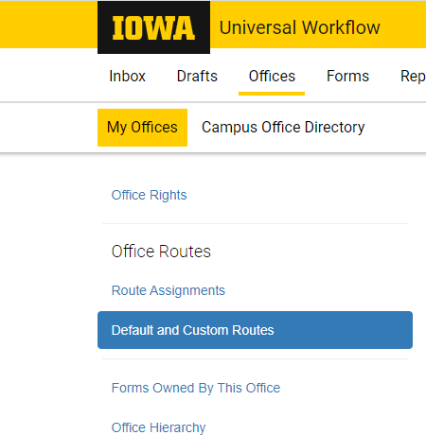

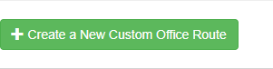
- Click the Create a New Custom Office Route button on the bottom of the page.
- Name the custom route you are creating for your department. For example, Monetary Proposal Routing Form.
- Click the “Add New Stop” button in the upper right corner.
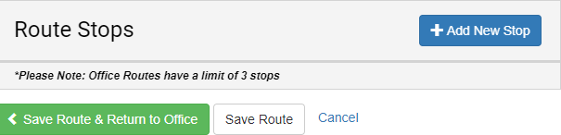

- Add a Name for the new stop.
- Choose the role where you would like to have the workflow stop. A common choice is the departmental PARA which is Pre-Award Research Administrator-Department or DEO of department.
- Set up the details for the stop. This includes:
  - Approver Rights-Is a signature required or permitted? Or View Only. (Do not choose Edit Only)
  - Escalation Rules if desired (DSP setting or leave it to department?)
  - Allow Delegation
  - Allow Out of Office
  - Can Not Resolve Rules-actions needed if workflow is halted at this stop.
- Update Destination

Connecting a Custom Route to a Form

- Click on the Offices option in the top toolbar.
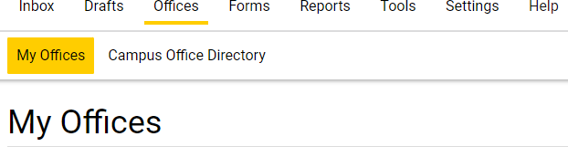

- Under Departments, Click on the link to your department.

- Click Route Assignments on the left hand toolbar.
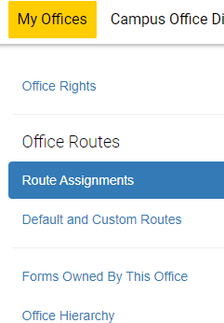

- Find Monetary Proposal Routing Form from the list. They are in alphabetical order.

- Click the drop down box for that form and choose the new custom route that you created.
- Confirm changes.

