Instructions for Editing Routing Form while in Workflow

You can edit certain fields within the routing form while it is in workflow.
- To edit these fields, click the Edit button in the upper right corner of the form.
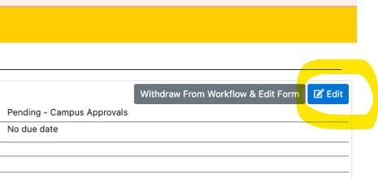
- Once the edits have been made, click the Save button in the upper right corner.

Fields that can NOT be edited while the form is in workflow are:
Contact PI, Co-PIs, co-Investigators or key personnel.
Workflow Approving department once it has been submitted to Workflow.

