Instructions on Approving Routing Form in Workflow

- Login and open your workflow inbox. https://workflow.uiowa.edu/inbox

- Make sure the My Inbox is selected. The Monetary Proposal Routing Form will be listed.

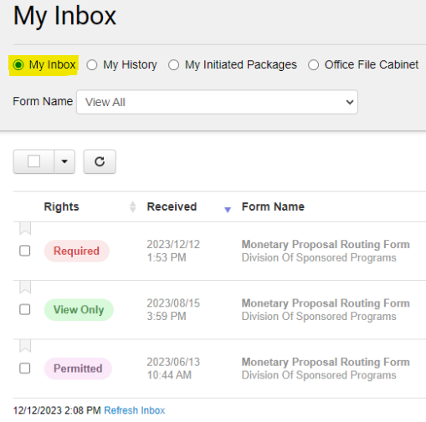

- Select the form you want to review and approve.

- Review the form and navigate to the Workflow tab on the left-hand side of the form and click the green Approve Package button.

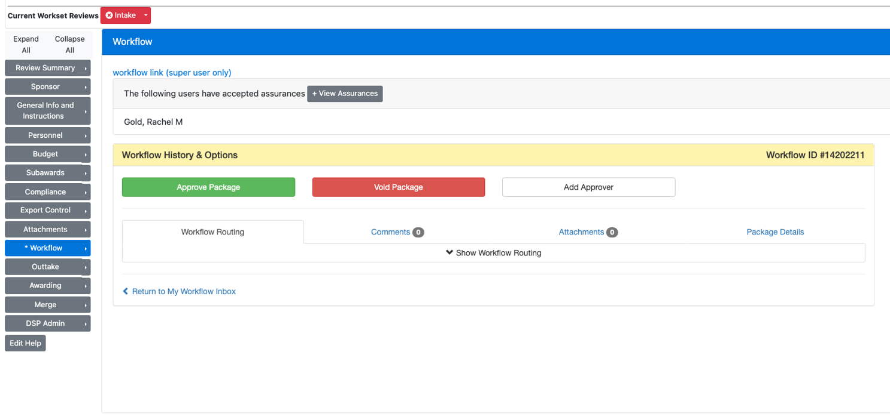

5. A popup will appear on how to review and approve the assurances. Click Continue.

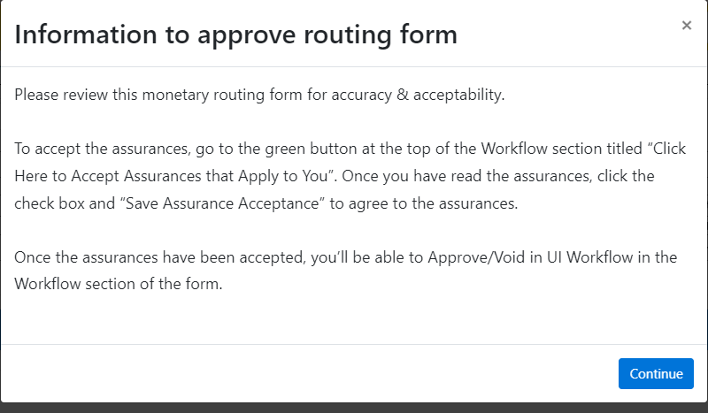

- Follow the directions in the popup. After reviewing the routing form, navigate to the Workflow Tab and click on the Click Here to Accept Assurances that Apply to You button.

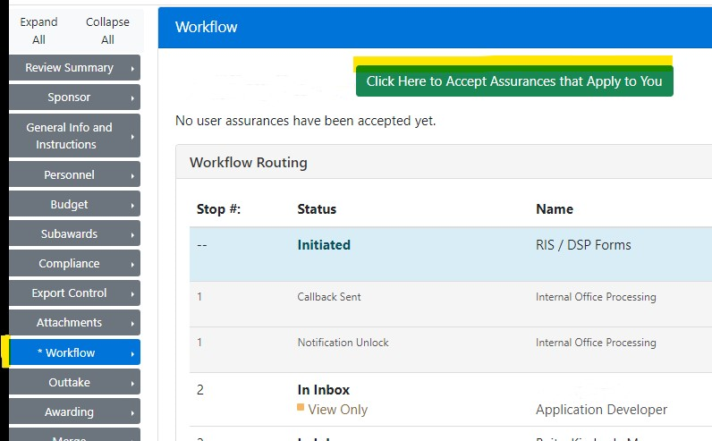

- Read and accept the assurances by checking the box and clicking the Save Assurance Acceptance (click checkbox above first to enable) button.
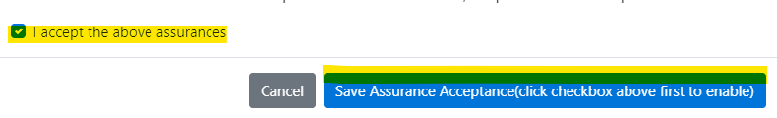

- A popup box will appear that the assurances were saved. Click to OK button.

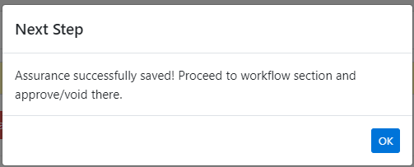

- Navigate to the workflow tab to approve the form. Click the Approve Package button.

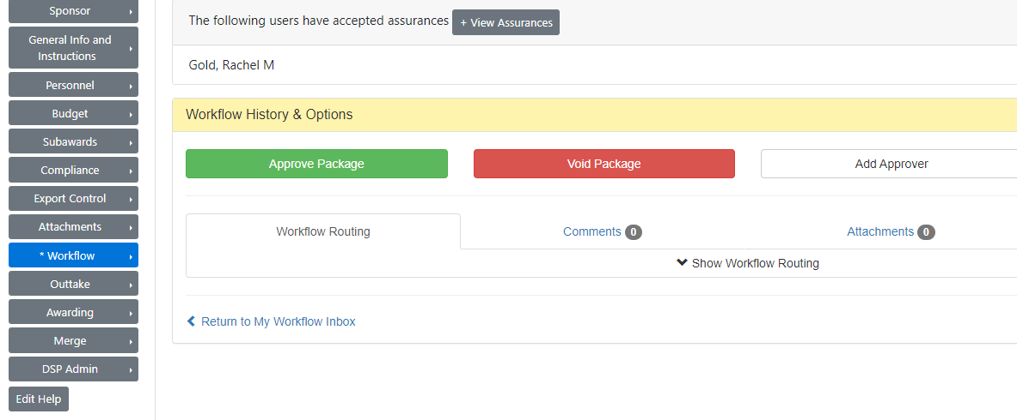

- A popup will appear to confirm the approval. Click the Approve Package button.
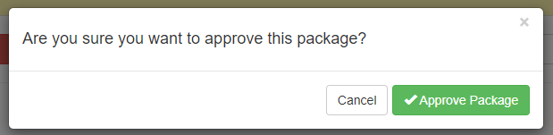

- The routing form will move from the Workflow Inbox to My History. You can view it by selecting the My History radio button.

