Withdraw Routing Form from Workflow for Editing and Resubmission

You can withdraw a routing form from Workflow to edit it and resubmit. The form will need to go through the entire routing process again. To withdraw a form and edit it:
- Click on the Withdraw From Workflow & Edit Form button in the upper right corner of the routing form.
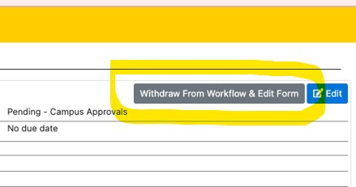
- Give a reason for the withdraw. Explain what and why you are making edits. The text will be displayed to approvers when the form is resubmitted. Then click the Yes button to withdraw the routing form and edit it in draft.
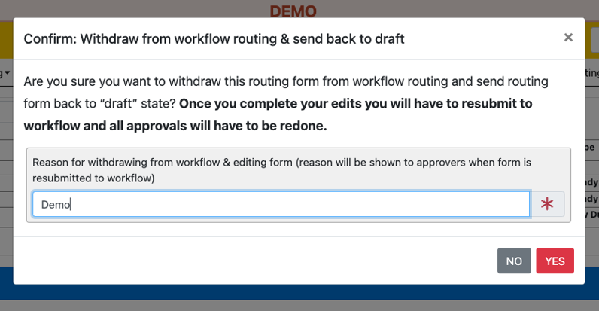
- Once edits are completed. Click the Save & Submit to Workflow button in the upper right corner of the form.
